Rules to abide by during camp for everyone’s safety and enjoyment

Have FUN! This should be the main goal for every person at camp and do your best to ensure your dog is having fun too! Of course, don’t let your fun interfere with another person or dog’s fun or safety.

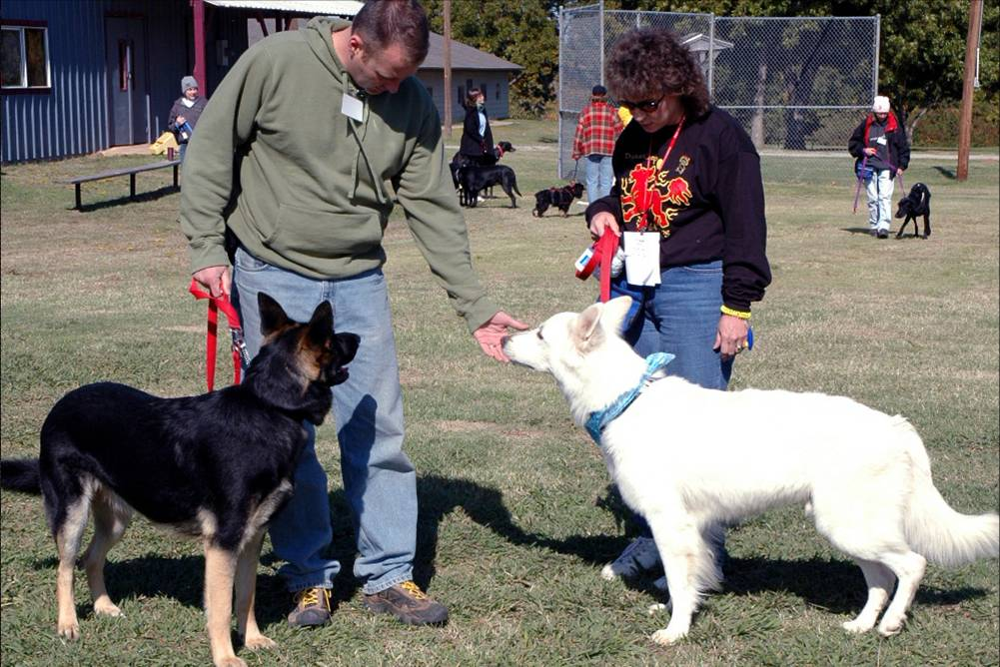
General Safety:
Be proactive in keeping your dog safe and out of trouble.
Watch for signs of stress or aggression. Keep your dog at
a safe distance from other dogs unless it’s clear the other
dog and person are okay with your dog getting close. This
is especially true upon arrival and during day one when the
dogs and people are a bit stressed by all the new sights,
sounds, smells and fellow campers they don’t yet know.
This is also before campers may have had a chance to get
a safety bandana described below.

Barking Dogs:
If your dog barks at another dog or person, do your best to quickly get his attention back on you to interrupt that barking behavior. Use his most favorite treats or toy in front of his nose to move him back toward you or use your movement away from the other dog/person to get your dog’s attention back. Try having the dog do simple behaviors he knows well that you can reward to refocus his attention on you (sit, down, touch, etc.) and to get him back to thinking mode and out of reactive mode. If your dog gets barked at, get his attention back on you and give the other dog some space. By getting your dog to look away from the barking dog, you help your dog give a “calming signal” to that dog to tell him your dog doesn’t want to fight. If you allow your dog to stare at, or bark at the barking dog then the opposite signal (“let’s rumble”) is sent.
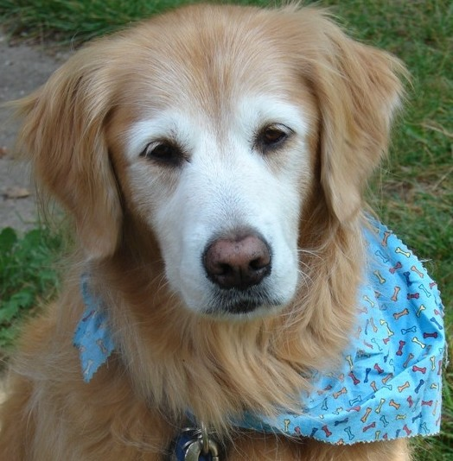
Safety Bandanas:
Yellow bandannas are for dogs that don’t like other dogs in close proximity. Please respect this unspoken request to keep your dog back & give extra space.
Multi-colored striped bandanas are for dogs that are uncomfortable with unknown people touching them or getting in their space. Please do not approach this dog without an express invitation from the owner.
Blue bandanas with bones on them are for dogs with food allergies or dogs that the owner doesn’t want people to give treats to. Because of dogs with severe food allergies, please pick up any dropped treats if your dog doesn’t beat you to them. :-)

Smoking/Alcohol:
There is a strict policy of NO alcohol or smoking allowed on Lakeview Camp property. Please be respectful of this camp rule. Anyone who breaks this rule will be asked by camp staff to leave the property and additionally, DSA could face fines as a result.

Medical Emergencies:
If there is a medical emergency, have someone advise a staff member as soon as possible. You can use 911 to call emergency services for a human emergency. There will be a map, address and phone number to the nearest vet and human urgent care clinic posted in Cindy’s office in the Dogwood Room as well as in all the cabins. There will be a first aid kit in the Dogwood Room as well.
All injuries and incidents must be reported to staff so they can be documented as soon as possible after the incident. If you witnessed an injury or an accident, please let staff know so we can include what you saw on the report. This includes both human incidents/injuries and dog incidents/injuries.

Leaving Camp/ Going to Town:
If you go to town or leave camp for any reason, please let Mart or Cindy know when you are leaving and the estimated time of arrival back at camp. If you have a cell phone, please text Cindy’s phone so we are aware of when to expect you back and have a contact number for you. If a little while turns into much longer, it would be helpful if we have a way to check on your welfare so we don’t have to worry and wonder. If you decide camp is not for you and you want to leave, please let a staff member know. We don’t want to have to dredge the lake for you because we think you have gone missing!

Look out for the welfare of your fellow campers. If you notice someone has not been seen for a while or someone seems to be having a bad time, please let a staff person know.
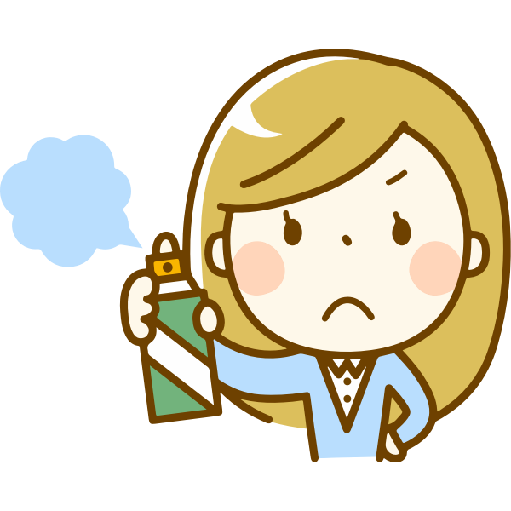
Bug Spray/ Perfume:
Some of the staff and/or campers may be chemically sensitive. In an
effort to help them enjoy camp without feeling ill, we request that bug
spray only be applied outside and that perfume use be kept to a
minimum, if at all. It’s camp; no one expects you to look and smell fancy
anyway :-) If you need to groom or spray treatments/bug spray on your
dog only do this outside as well.

General Rules:
Each person is responsible for watching their dogs for elimination and cleaning up after them! If you let your dog off-leash in the play yard, be sure to watch them carefully. On trails, your dog should not get out of your sight. Place collected waste into the 5-gallon buckets found around camp. Be sure the waste is sealed inside a clean-up bag.

Help keep your camp beautiful. Everybody is expected to clean up their own room and help clean up camp both during camp and before leaving. Scouts always leave things cleaner than they found them.

Please respect camp and troop property and use it with care. Return any items that you use to the storage place where they belong (even if that’s not where you found them). If anything gets damaged, please let staff know immediately (especially if it creates a safety hazard). If you or your dog damages or breaks camp property, you may be asked to replace it or pay for the replacement. If you groom your dog, please do so outside. If you get a lot of hair off your dog, please clean it up. While the birds can use a little bit of hair, it is unsightly to see a spot where it looks like a dog exploded all the hair off his body. Please clean up any dog hair your dog leaves inside any of the buildings or cabins.

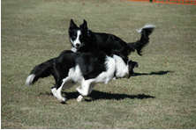
Off-leash play yard rules:
Some additional rules and safety info about the play yard (and other aspects of camp) is found in the “General Instructions” info found in the camp section of the DSA website pre-camp reading material. Be sure you have read that info as well.

If the person or persons already in the play yard are okay with your dog joining theirs, there are some things you can do to make the entry of your dog safer and less stressful.
Each person in the play yard should call their dog to them and hold their dog’s collar till the new dog is in and off-leash. Move the new dog away from the entrance and then the dogs can be released ONE AT A TIME to greet the new dog. This will help prevent the new dog from feeling overwhelmed and/or being mobbed and/or cornered by the dogs already in the play yard.

Be sure as you exit that no other dog is trying to sneak out with you. If there is a dog trying to get out of the gate ask the owner to call him/her away before you open the gate.

Use toys in this area wisely. If they seem to be causing a guarding issue, put the toys outside the fence or remove the guarding dog.

If anyone is waiting to use the area, please limit your time in there. Perhaps it is someone with a dog that needs to use the area alone, or that is not compatible with the dogs currently in the yard. Or maybe it’s your dog that needs to be in the yard alone.

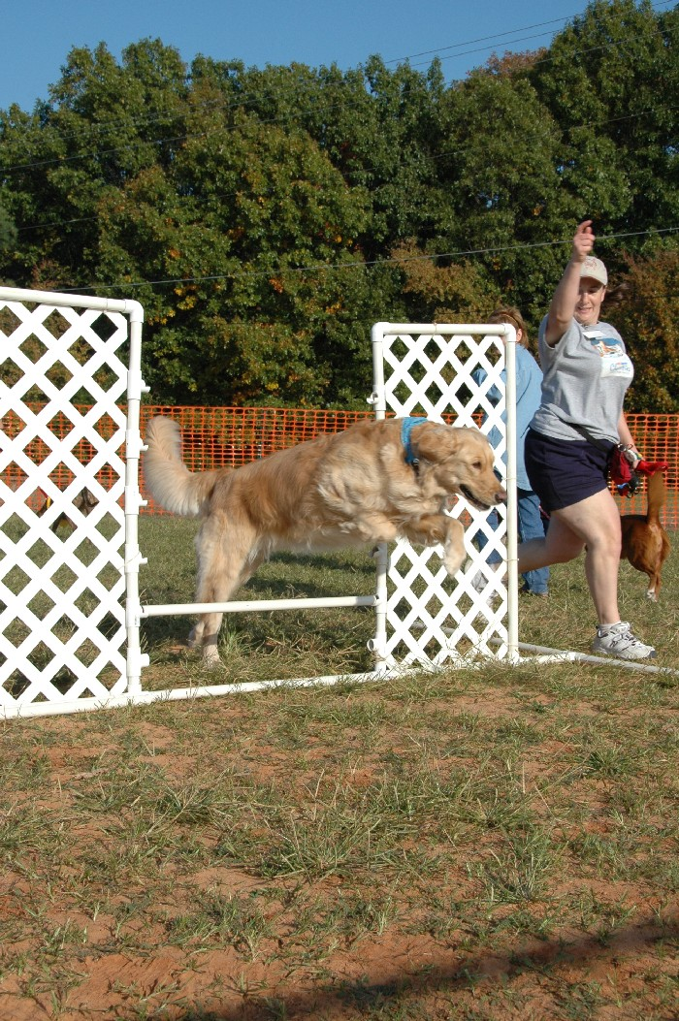
Agility field rules:
We ask that you attend the O&S on Agility before you allow
your dog on the camp agility equipment. If you have been
competing in agility with the dog you brought to camp, you may
use the equipment but need to have a buddy on the field or
have someone within shouting distance that could help you if
you were to fall. Anyone wanting to do agility practice outside
the regularly scheduled agility class times, needs to have
pre-approval from one of the agility instructors.

Please be sure your dog eliminates BEFORE bringing him onto
the agility field. Having dogs mark or leave presents in this area
increases the chances that a dog on course will get distracted
by the scents left behind. Do your best to clean-up any accidents
that occur on the agility field.

Agility training is physical! This is true for you and the dog. Be sure you are ready for aerobic exercise in the potentially warm weather before going on the field. Watch yourself and your dog for signs of over-heating and take frequent breaks in the shade.

Because you may be running and bending, dropped treats and accidently dumped treat bags are more likely. Be extra vigilant that you pick-up any treats you or your dog may drop.

The Agility equipment is sturdy, but not all the equipment is built with the same materials as you might find at a competition. If there are any pieces of equipment you are not comfortable with your dog using, then choose to skip that piece.

If multiple people are on the field (like in class) be incredibly careful to keep your dog near you so that he doesn’t get in the face or go zooming past a yellow bandanna dog. If you or your dog needs special assistance, the instructors are often happy to accommodate you. But if you are requesting help during a time when agility class is not scheduled, be respectful of the instructor’s personal time. Instructors are also at camp to enjoy camp with their own dog and may be teaching multiple classes.

Campers with experience are encouraged to help those new to the sport. Just be sure to use only non-punishment, reward-based training methods.

At no time are humans allowed on the agility equipment!

Camp Lake rules:
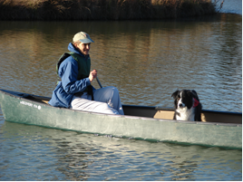
There are plenty of non-class times when you can use the lake
simply for your dog’s enjoyment. However, please do not use
any camp boating or recreational equipment without
express permission from a member of the Camp staff.
Lakeview Camp requires a lifeguard be on duty anytime there
are humans in the water. Lifejackets are required for all humans
in any of the boats or paddleboats.

If your dog is toy possessive and might fight over a toy, do your
best to only have him play at times when other dogs are not
close or by giving him enough distance that you feel the other
dogs are safe and not likely to bother your dog. Also advise
anyone that arrives in the area that your dog may guard toys
so they know to keep their dogs back.

Store Rules:
Each person is responsible for adding the items they what to purchase from the store onto their page of the camp tab book. Each person runs a tab and then pays before leaving camp with a check or cash. You can put the purchased items on your tab to use immediately; you don’t need to wait until you pay to remove your items from the store. But we do ask that each item be added to your tab page before it exits the store. We trust you to be honest.

There will be a price sheet posted and most items will be marked with the prices. However, if you can’t find the price of something, just leave that part blank on your tab and be descriptive about the item you purchased so the price can be filled in later. If you need help deciding which item or size you or your dog needs, you may take items from the store back to your cabin to try on for size. However, still please mark the items on your camp tab. If you return an item that didn’t work, simply scratch it off your tab.

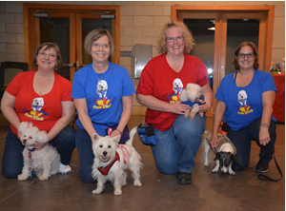
Roommate rules:
You will be sharing rooms, so please follow basic
common sense and courtesy rules. Treat others
as you would want them to treat you. Keep the
amount of space you use in the room to a minimum.

Be sure your dog is securely confined away from
the door of the room any time you will be leaving
the room. Your roommates should not need to
worry about accidently letting your dog escape
if they need to get into the room. Dogs are to be
secured in a crate (x-pens are not crates) any
time you are not in the room and your dog is not
directly under your supervision.

Keep your dog OUT of crates, bowls, toys and beds of your roommates and their dogs. If your dog DOES get loose and eats or damages anyone else’s stuff, you are responsible for replacing it or providing compensation to the owner.

Store your treats, dog food and any other potential edibles or dangerous items (meds, etc.) out of the reach of dogs. The cabins all have a common room which would be a good location to keep edibles or meds. You may also use the top bunks in the rooms to put things out of the dogs’ reach.

If you must get up during the night, be very quiet, and use a small, dim light, that will not blind everyone else (don’t turn on the overhead light.)

Remove your dog’s jingling tags, put a tag silencer on them (available in the camp store!) or bring some rubber bands to wrap around the tags at bedtime. Keep your dog’s nails trimmed short and don’t let him roam during the night. He should be crated or tethered to your bed.

Respect quiet time (11pm to 7am) and do your best not to make any more noise than you would in a sleeping baby’s room. Even if the people in your room are not sleeping, others in the cabin likely are trying to sleep.

You may want to bring a small fan for “white noise” and to circulate the air in your room. You can bring rugs for your room to help deaden the sound (they also help collect dirt so it won’t get into your bed and they also eliminate the toenail clicking sound.)

Remember there is just one thermostat per cabin that controls both bunkrooms. Please be considerate of the campers in the other bunkroom when adjusting the temperature for the cabin.

Overall, just follow the golden rule and we should all get along fine! 😊

