Agility Partners
Criteria and Course Designs

This is an advanced agility badge designed to improve teamwork between handlers and dogs. Through the completion of 9 drills, handlers will improve their ability to handle their dog efficiently in varied course situations. Dogs must understand course sequencing before attempting this badge. Each of the courses must be completed exactly as designed. Because the skills required for this badge are specifically designed to build the agility partnership, each handler must complete the requirements with his or her own dog.

Handling Skills

The act of the handler changing sides with a dog while moving through an agility sequence or course is called a “cross.” Crosses are necessary to be able to get from one side to the other without causing delay or confusion; they are designed to accomplish a change of side in order to preserve the flow of the sequence. The type of cross the handler chooses can drastically improve the dog’s success on course. Choosing the most applicable cross eases the course for the handler as it may require fewer steps.

Front Cross
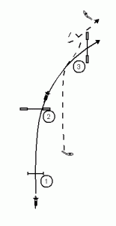

A front cross occurs when the handler crosses the course path ahead of the dog and changes sides with the dog in order to continue smoothly. The dog turns toward the handler, performing an inside turn.

https://youtu.be/r6F0x31ripI

Rear Cross
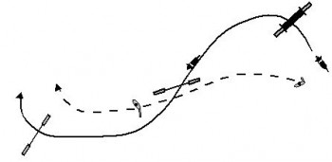
A rear cross happens when the handler sends the dog ahead on the course path and crosses behind him. The dog turns away from the handler, performing an outside turn in order to be on the other side of the handler when the obstacle is completed.

https://youtu.be/4VeX0sN0Gpc

Blind cross
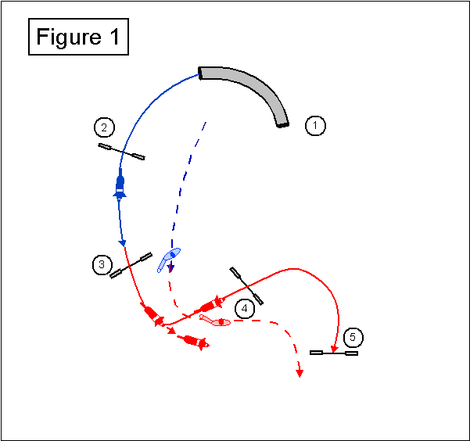

A Blind Cross is a maneuver in which the handler changes sides in front of the dog. To accomplish this cross the handler quickly turns his back on the dog.

https://youtu.be/Tf2jN41j2B8

Shoulder Pull

The handlers shoulders are among the best tools a handler has when guiding a dog through an Agility course. Because of this it’s imperative that the handler is always aware of what his shoulders are communicating to the dog. One easy way to understand this concept is for the handler to run a course with his hands behind his back. Without hand/arm cues the shoulders feature quite prominently but the movement of the shoulders is essentially the same with or without these cues. With course designs that include threadles or serpentines the pull of the shoulders becomes every bit as important as any other handler movement.

The shoulder pull is a basic agility maneuver where the handler turns the dog while remaining on the same side. A shoulder pull may be used on its own or used in a more advanced combination before or after a cross. Though it may require more thought on the part of the handler the pairing of a shoulder pull with a cross is an extremely easy cue for the dog to read.

The illustration below shows the handlers use of the shoulder pull to bring the dog around the circular pattern of jumps. There is little movement on the part of the handler other than a rotation in place while the shoulder leads the dog. Depending on elements of the course coming before or after this circular pattern, the shoulder pull may be combined with a cross.

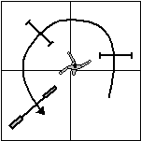

Straight Line/Distance Challenges

When a dog can work at a distance the handler is able to improve on course efficiency. Dogs can move faster than handlers so in order to clock a faster time the dog must be able to move through a course confidently even when the handler is not right along side. Both courses illustrated below must be completed per badge requirements. It is recommended that handlers learn to work both at a distance however only one is required at a distance to earn the badge. Additionally, dog must complete a distance challenge of at least 2 jumps using either course below, with the handler remaining behind the plane of the first jump and sending the dog out.

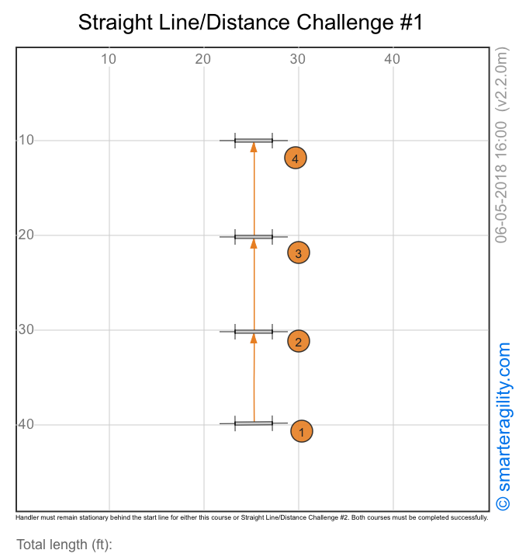

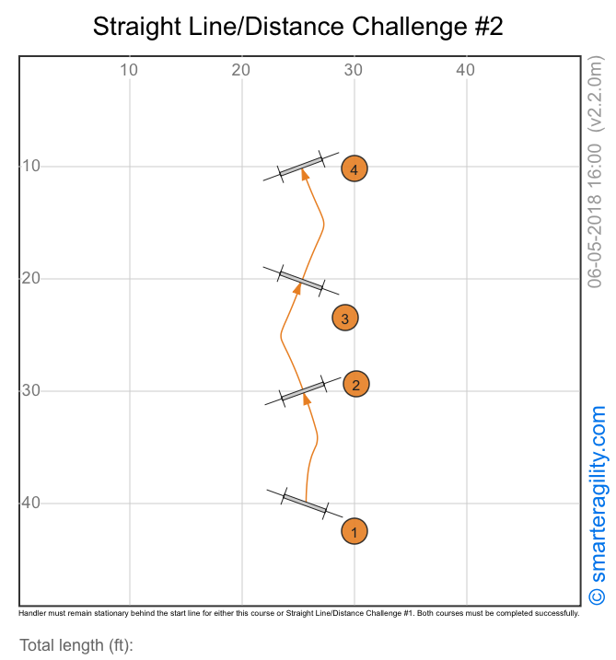

4-leaf Clover (Stationary Handler) Drill

This drill should be completed with the handler on the inside of the cloverleaf. Though the handlers feet do not need to remain completely stationary, foot movement should be minimal and may not cross the plane of any jump at any time. The shoulder pull is an important tool for the handler to use when completing this drill.

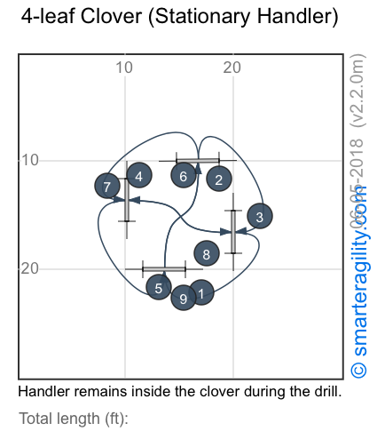

Offset Serpentine Drill

For this drill the handler must determine the most efficient way to handle his dog. There is quite a bit of opportunity for the dog to take an obstacle out of sequence if not cued properly. There is also a lot of opportunity for the handler to miscue due to the relative tightness of the course. Handlers will likely find benefit in the shoulder pull in completing this drill. The goal is to move smoothly and efficiently with the flow of the course.

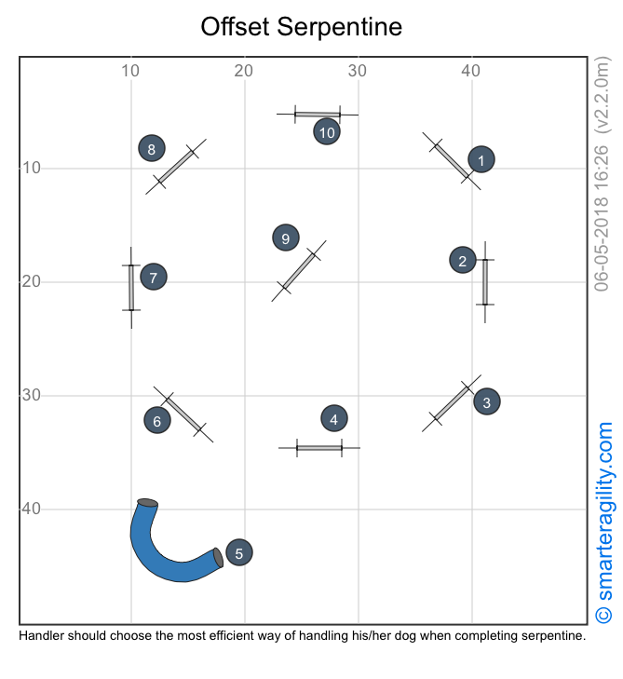

Reverse Flow with Circle Drill

Reverse Flow is a fun element for both dog and handler when used in a course design. The term applies to any part of a course sequence where the dog travels the same path going out and back, most often in combination with other elements that interrupt an immediate reversal. Distance work is needed here as well as an effective shoulder pull in the circle in order to be most efficient. The best handler/dog teams can complete the drill with the handler remaining essentially stationary inside the circle.
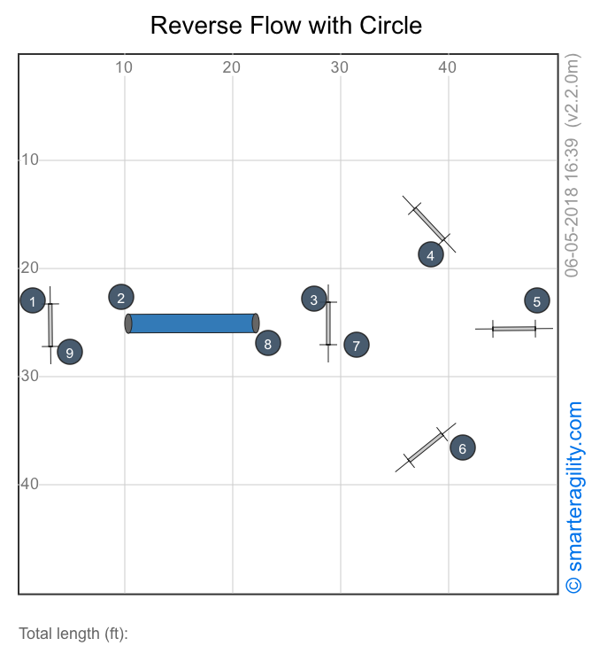

Speed Circles (Timed Drill)

Drills designed to build speed are generally very fun for dogs. This one combines speed with a circle pattern intended to build drive, confidence and speed in the dog. Dogs with a naturally high drive will be delighted with this drill. The drill must be completed in 25 seconds or less and the handler must bring the dog back to center to stop the clock.
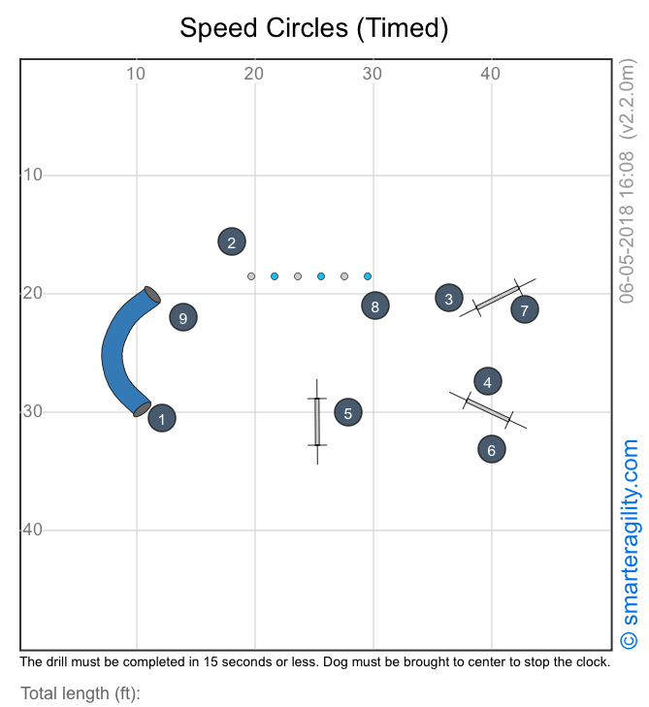

Weave Entry Challenge (Timed Drill)

The challenge in this timed drill is primarily in the difficulty of the weave entry. The abrupt change in direction from #3 to #4 will cause some dogs to miss the entry entirely, but mastering this challenge makes for a much more adaptable and versatile dog. The handler must consider the best position to be in to support the dog’s movement from the tunnel exit to the #2 jump and again to support the weave entry, all within a relatively small space. This drill must be completed in 15 seconds or less.

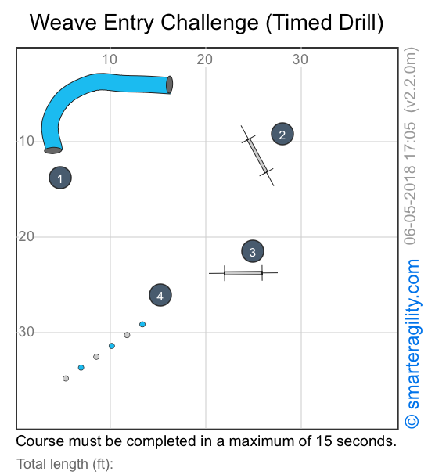

Speed Weaves (Timed Drill)

The challenge is this drill lies in the combination of tunnels and weaves. After moving quickly through two fast, straight tunnels the dog then has to slow in order to make the weave Entry the second time around. The handler should try several different handler positions to determine what is most effective in moving the dog quickly enough yet still have the dog to maintain enough control to make the weave entry. The course must be completed in 25 seconds or less.
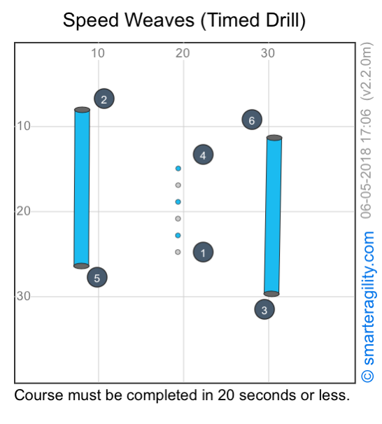

Backside Threadles w/Pull

Jumps #3, #4 and #5 make up the threadles and present the challenge in this drill. The key is to get the
dog to wrap through the jumps with very little unnecessary movement. Studying the path of the dog can be helpful in figuring this out but it can be difficult for the handler to get the necessary view while running the dog. For this reason it’s great for the handler to have someone else available to watch carefully and help. Even better, have two people available. One person to watch the dog’s path and one to focus on the handler’s movements. The handler should make good use of a shoulder pull when completing this course. Dogs that are most efficient in completing a course of this type take a path through the threadles that moves from #3 through #5 in a straight line facing the left side of the course. A straight tunnel may replace jumps #7 and #8 if preferred.
