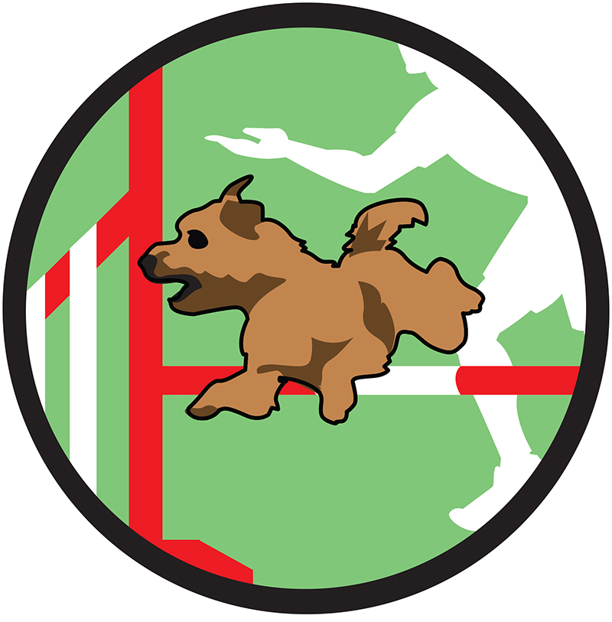

Dog Scouts of America

Agility Partners

Merit Badge

Dog’s Name: _____________________,DSA Handler: ________________________

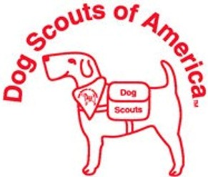This certificate certifies that the dog and handler team above have fulfilled the requirements of this Merit Badge, according to the high standards set out by Dog Scouts of America. This dog was trained to perform the specified behaviors using positive training and the handler demonstrated the required knowledge.

Handler Signature: _____________________________ Date: ___________

Evaluator Signature: ____________________________ Date: ___________





Cut at line above, keep top portion for your records, and send the bottom portion to DSA for processing.

**Instructions:**

1. Fill out this form completely and **legibly**. Once the badge requirements are met, the Evaluator (in-person or by Distance Evaluator) will sign the completed form certifying that you and your dog met the badge requirements.
2. Cut the form at the designated line and mail only the bottom portion to the Merit Badge Recording Secretary – Julie Benson, 30911 Jasper Ridge, Novi, MI 48377
3. Video evaluations must be sent to [dsavideoeval@gmail@gmail.com](mailto:dsavideoeval@gmail@gmail.com). Email submission is required for video evaluations.
4. Include $25 in the form of a check or money order made payable to Dog Scouts of America.
5. Optional: Include $3 for each additional patch, if any, that you would like of this badge.



Agility Partners Badge Form

Dog’s Name: _______________________ DSA Handler’s Name: ___________________________

Full Mailing Address: _______________________________________________________________

Phone: (_____)______________ Email: ________________________________ Troop #: ________

I would like ______ additional patches of this merit badge (I have included for $3 each)

***The signatures below certify that the dog and handler team above have fulfilled the requirements of this Merit Badge, according to the standards set out by Dog Scouts of America. Signature of handler verifies that this dog was trained to perform the specified behaviors using positive training, the dog has earned the Dog Scout Title, and the handler is a current member in good standing of DSA.***

Evaluation done:

O In Person O At Camp

O By Video

Handler Signature: _________________________________ Date: _________

Evaluator Signature: ________________________________ Date: _________

Evaluator print name: ________________________________

For office use: ___/___/____ Rec’d ____ Verify Membership ____ Notified of needs ____ Database Entry

___/___/____ Mailed ____ Monthly tally ____ SM database ____ Verified Log