Weight Management

In order to help your dog stay a a healthy weight, you have to know what your dog’s weight should be, and what it is currently. While we rely on our veterinarians to weigh our dogs on visits and discuss any weight related issues with us, we are responsible for evaluating our dogs’ weight on an ongoing basis. Only by knowing whether a dog is overweight or underweight can we properly react to the situation.

An estimated 53% of dogs are overweight yet nearly half of owners of overweight dogs incorrectly believe that their overweight or obese dogs are at a normal weight. These owners usually fail to identify factors that contribute to obesity including poor quality food, access to too much food, too many treats and lack of exercise. Consider a Chihuahua that should weigh 5 lbs. Each extra pound this dog gains represents a 20% weight gain roughly equivalent to a gain of 30 lbs. for an average sized man.
Identifying weight gain in a small dog may be easier to catch early but it is just as dangerous in larger dogs. The same 1 lb. weight gain in a 50 lb. dog represents a 2% increase in weight and won't be noticed as quickly as in a smaller dog simply due to size.

Small, low-activity dogs need only about 185 to 370 calories daily, while large dogs, between 67 to 88 pounds may need between 1,000 to 2,000 calories, depending on activity level and gender. Yet many of our dogs get far more food than they need.
Treats can be one of the biggest contributors to weight gain in dogs as they are rarely included when calculating what a dog consumes each day. Most people don't think twice about giving their dogs a medium sized dog biscuit as a treat. Yet for a dog this treat can be the equivalent to a human eating an entire cheeseburger. A 40 lb. dog who consumes a pigs ear or bully stick is roughly the same as an adult human drinking six 12 oz. cans of soda. A typical dog biscuit to a 20 lb. dog is roughly equivalent to 2 double stuffed Oreos to an average person. These facts clearly illustrate why it is so important to help our dogs maintain a healthy weight or lose weight if needed.

Knowing what your dog weighs can be a challenge since most of us don't have a veterinary scale at home. Small and medium dogs can easily be weighed using a typical home scale by first weighing yourself, then weighing yourself holding the dog and subtracting your weight from the total. This can be a challenge with a larger dog though so a better solution is to drop by your veterinarian’s office. Most don't mind their clients dropping in for a weight and they love getting to see their clients focusing on their dog’s weight. Or, take your dog with you to the pet store. Many stores have veterinary clinics with scales right at the counter. Your dog will love getting special attention from everyone in the store and together you can pick up a new toy in order to get more exercise at home.

Solving the challenge of how you will weigh your dog on a regular basis is important but weighing your dog regularly only helps you if you know what your dog should weigh. Breed standards for height and weight is a good place to start, but your veterinarian is the best source for info on what your dog should weigh and how to maintain a healthy weight.

Most veterinarians use a scoring system for weight using a range of 1 to 5 where 1 is emaciated , 5 is obese and 3 is ideal. Veterinary schools are developing another formula for describing weight. This method uses 6 different body measurements and the dog’s weight. The result is a Body Fat Index (BFI), much like BMI in humans

Using the descriptors from current scoring method can provide clues to a dog’s weight even if a scale is unavailable for a period of time. These descriptors allow for a visual assessment of the dog. Additionally, laying hands on the sides of a dog should allow you to easily feel the ribs under a thin layer of fat. Feel is especially important for dogs with profuse coats that may obscure weight cues that might otherwise be easily visible.

Check with your veterinarian prior to beginning a weight loss plan with your dog. Your vet will help you develop a specific plan for your dog. Most plans include a cut in food by as much as 25% and a gradual increase in exercise level. Some dogs are couch potatoes so it's best not to leave the decision to exercise up to them. Healthy dogs with no exercise restrictions should generally have two 30-minute walks each day. Increases in exercise may mean that the dog’s food does not have to be decreased by as much, so play should be encouraged.

Since obesity is considered to be epidemic in dogs, weight management is just as important for dogs as it is for humans. In fact, obese dogs are prone to some of the same medical issues as their human counterparts, including diabetes, heart and respiratory disease, hypertension, arthritis and an increased risk of cancer. Overweight dogs on average live about 2.5 years less than dogs at normal, healthy weights. In human terms, that's equivalent to 38 years!

Though far less common, a dog who is underweight will likely experience health concerns as well including excessive shedding, dry skin, poor regulation of body temperature, loss of muscle mass, and heart problems. Malnourishment in dogs is most often a symptom of another, maybe serious health issue. As with humans, any sudden weight gain or loss or change in appetite should be evaluated as soon as possible.

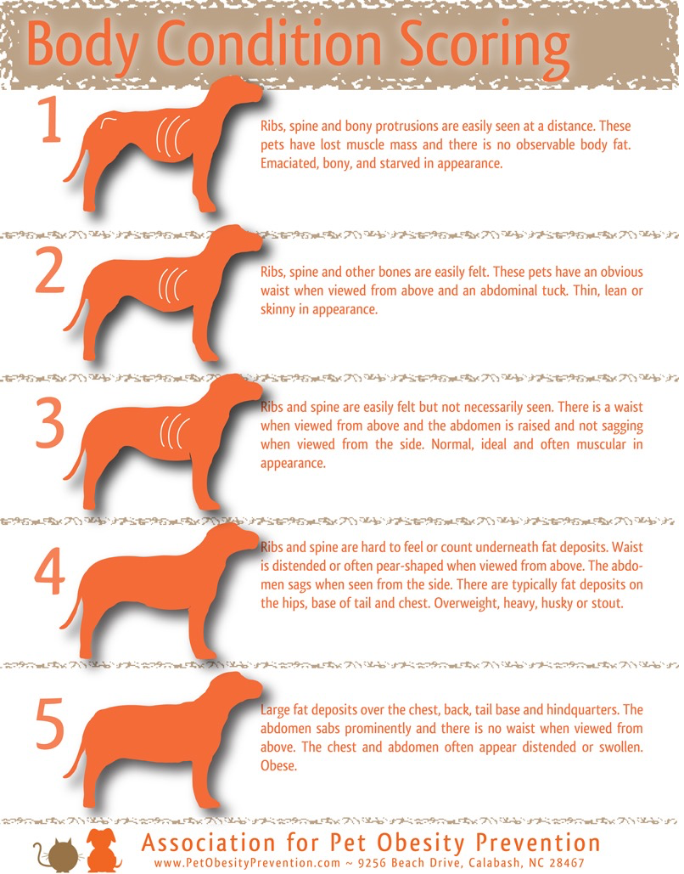
A Visual Guide to Weight Management

