SAR Agility

This badge is intended to simulate the “agility” training a dog might go through to prepare for the navigation of rubble and/or collapsed buildings to search for trapped people. Because every search site is different, this badge incorporates some “core” behaviors that are likely to be needed at most sites or that are important for the dog to know. These behaviors will be demonstrated using obstacles that are built for the badge or can be created from what the handler or instructor has available as long as the guidelines are met.

This badge is not intended for all dogs and the safety of the dogs attempting the training for this badge is a top priority. Any dog with a physical ailment or weakness that affects the dog's ability to navigate and balance safely should not try this equipment. And any dog under 18 mo. old (growth plates not closed) may not earn the badge and should not be working on the equipment at full height or doing obstacles that put stress on the dog’s joints. For the safety of the dog, no obstacle may be higher than an AKC Agility Dog Walk (48”) and care should be exercised when teaching a dog to navigate any raised obstacle.

If an instructor tells you to stop your dog or that this might not be the best badge for your dog, please respect that. The instructor knows your dog’s safety and confidence is paramount. The dog must demonstrate confidence with the required behaviors in order to earn the badge. During training, no dog showing fear or apprehension should by pushed to do anything beyond his comfort level, but may be encouraged with rewards to move ahead in the training at a pace that doesn’t overly stress the dog.

Skills needed to earn this advanced level badge (items in bold defined below):

- Prior to starting this training, the handler will get DSA approval of equipment that will be used to show that it is safe and within DSA guidelines. Photos can be submitted prior to video evaluations.
- Handler understands and can articulate safety concerns and potential risks
- Handler can stop the dog at a distance with a verbal or visual signal while dog is performing an obstacle (when it is safe to do so)
- Handler demonstrates during training that he/she can read the dog's confidence levels and will demonstrate at least some of their training steps to the evaluator.
- Handler can demonstrate or explain how to help the dog gain confidence to try new skills using positive reinforcement
- Handler can describe injuries and other issues they want to watch for in their dog while doing this sort of training or SAR work.
- Handler agrees to accept and assume the risk involved in training for and performing this activity
- Dog has earned the Dog Scout Agility 1 or 2 badge
- Dog demonstrates confidence in performing all of the required behaviors
- Dog can perform various proprioception exercises demonstrating both balance and foot placement exercises BEFORE attempting any of the SAR Agility obstacles at full height
- Dog can climb a “ladder” to reach an elevated surface
- Dog demonstrates the proprioception to cross a horizontal, elevated “ladder”
- Dog will cross an obstacle that moves under him
- Dog will walk across a pipe or simulated pipe
- Dog will jump onto a sturdy elevated surface that is 1.5 to 2 times his height
- Dog will jump over an opening (between sturdy raised surfaces) that is 1.5 (+/- 4”) times as wide as the dog’s height and not more than twice the dog’s height off the ground (12” dog will jump over an 18” to 22” opening that is no more than 24” off the ground)
- Dog will jump from one height surface to another height surface that is higher or lower than the first surface by at least half the dog’s height and that is not the ground.
- Dog will crawl under a solid surface or through a tunnel that is the height of the dog’s shoulders/withers when the dog is laying down in the sphinx position (can add up to 1.5” if needed)
- Dog can be directed to go and perform at least 1 low obstacle at a distance (at least 15’ from the handler)
- Handler can stop the dog at a distance with a verbal or visual signal while dog is performing an obstacle (when it is safe to do so)
- Handler demonstrates during training that he/she can read the dog's confidence levels and will demonstrate at least some of their training steps to the evaluator.
- Handler understands and can articulate safety concerns and potential risks
- Handler can demonstrate or explain how to help the dog gain confidence to try new skills using positive reinforcement
- Handler can describe injuries and other issues they want to watch for in their dog while doing this sort of training or SAR work.

More definition of what is meant by the text above:
Proprioception exercises- These are exercises or learned behaviors that help the dog understand that he has back feet, where all his feet are located and how to place or use them specifically. It also includes balance exercises for navigating narrow surfaces and surfaces that move. The more of these types of exercises that your dog knows, the more adept he will be at balancing and navigating difficult terrain. A dog that is not skilled in carefully placing his back feet, for example, may find the SAR Agility difficult or dangerous. These exercises help your dog in everything he does. Examples of acceptable proprioception exercises include:
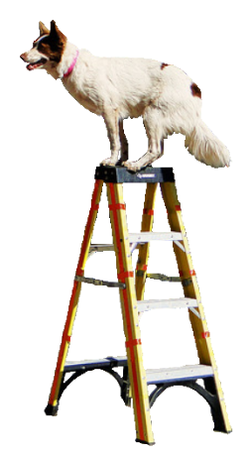
For balance- Balance balls and balance disks, all 4 feet on a wobble board, lifting feet on cue, handstands, etc.
For foot placement- walking through a ladder, trot poles, back foot targeting

Climb a ladder- For this exercise, a short 4’ ladder with open steps/rungs is ideal. Flat steps are safest because it gives the dog a solid place for his feet. The ladder should go to a safe raised surface for the dog (unlike the photo to the right). The dog should NOT jump off the top of the ladder. It can be built using 1x4 or 2x4 boards which is a good option for smaller dogs that might have trouble with the standard step spacing of a ladder or pallets that are secured from falling/moving can be used. The dog does need to CLIMB the ladder and not just jump over the rungs to the raised surface. For safety, be sure the ladder is stable and placed in a way that it doesn’t wobble or shake excessively. The ladder should be at a typical ladder angle; not vertical or excessively shallow.

Horizontal, elevated “ladder”- This should be at least 5’ long and not more than 3’ off the ground. The concept is a ladder laid across an opening to be used by the dog to get from one side to the other and shows that the dog has good control over his foot placement. The dog should be stepping on the ladder rungs and should not need assistance from the human (though the handler can be right next to the dog and act as a “spotter” by holding a harness on the dog (in a way that does not assist the dog) or by putting hands under the dog without contact. If the dog tries to “cheat” and use the sides of the ladder, you might need to build or use a wider ladder. Items that create the same behavior may be used in place of an actual ladder as long as the dog’s foot/leg won’t get caught if the dog slips and his leg/foot falls through. Alternate items need spaces between the rungs that are wide enough and rungs that are narrow enough to provide a challenge to the dog. The ladder should not wobble or move.
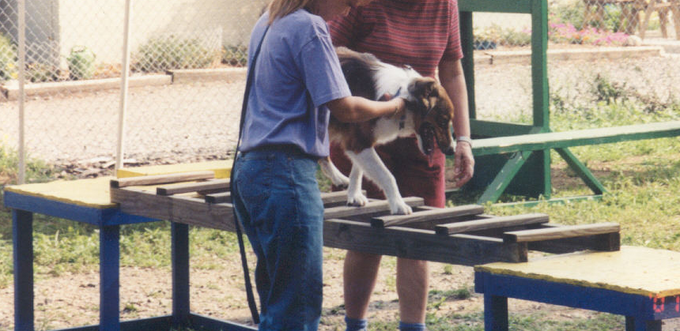
(Photo from: http://www.vincerambaladogtraining.com)

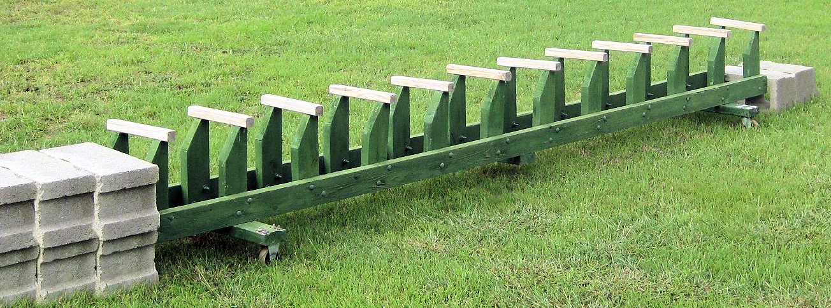
“Rail-less ladder”
(For dogs that try to use the sides of a standard ladder instead of the rungs)

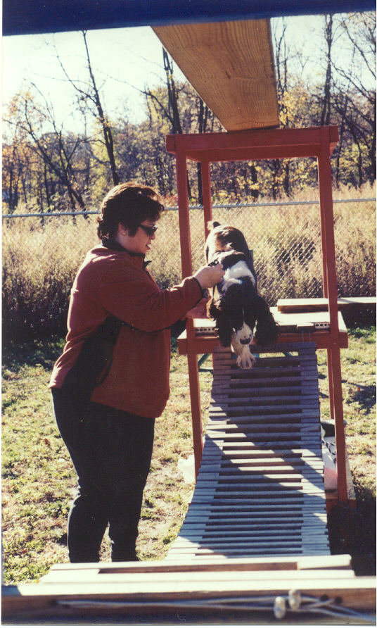
Obstacle that moves- This obstacle should provide a clear demonstration that the dog has no problem navigating an unstable surface. It should be constructed in such a way that the movement is not likely to catch or pinch the dog’s foot or cause it to slide off into a groove or opening. This is not a “touch n go” obstacle that the dog can get across by barely touching it. The dog should walk across the surface and the surface should be large/long enough that the dog can get all 4 feet on it during a normal walking stride. It should also not be a common item like a teeter or wobble board. For dogs not earning the badge at camp, some kid’s playgrounds have “bridges” that move and would work (as long as the bridge actually moves or is moved by the human as the dog crosses it). You can create your own by drilling holes in the ends of several planks and stringing a cable through them. Attach the cable ends to something solid. A UKC “Sway Bridge” or “Swing Plank” can be used if the dog walks across it and it moves and it is constructed to be long enough to accommodate a full stride. If other moving objects are used, they must be safe for the dog to navigate and not pose a risk of a foot or leg being caught/falling through or risk of a paw getting pinched.
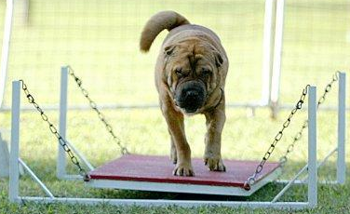
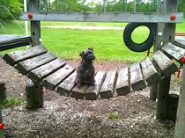
(MichiganDogTraininer.com) (ProDogGroomingSupplies.com)

Pipe or simulated pipe- The idea is to have the dog walk across something that is not flat, but that slopes away on either side like a pipe. You can put a 4x4 through a 12” pipe and secure the pipe to the 4x4 with screws so it doesn’t roll. Then set the ends of the 4x4 on a slightly raised surface to encourage the dog to walk on the pipe. Setting 55 gallon drums (straight sided barrels) end to end and securing them so they don’t move would also work. Using curved sided barrels this way would be fine too, just be sure to support the ends so they won’t wobble too much (unless also using it as the “obstacle that moves”). This obstacle should be the diameter of a 55 gallon drum/barrel or less (preferably less). Some dog parks, play grounds or construction sites may have suitable pipes (get permission if needed) for people earning the badge by video.
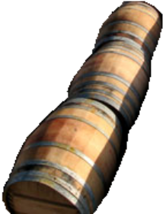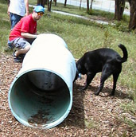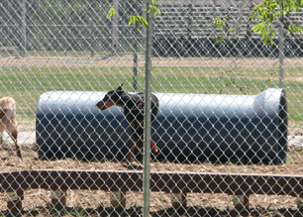
(spokanedogs.com) (doggoes.com/parks/utah)
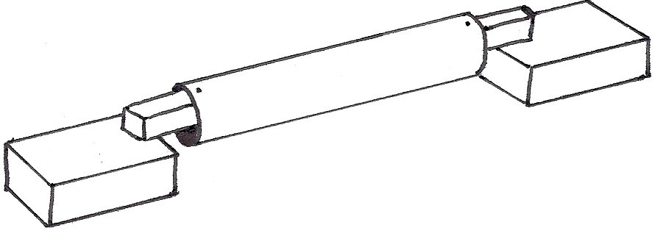

Sturdy elevated surface/ Jump over an opening/ Jump from one height to another-
In a disaster, it is likely that the dog would need to jump up onto raised surfaces and from one surface to another. For safety reasons, the surfaces used may not be more than twice the height of the dog at the highest point and not spaced more than twice the height of the dog apart. Ideally, the first surface would be about 1.5 times the height of the dog. The second surface would be twice the height of the dog and placed at least 1.5 times the dog’s height away from the first surface. Then the dog would jump onto surface 1, from surface 1 to surface 2 and back to surface 1. But these suggestions can be adjusted based on the surfaces available as long as the dog does not get more than twice his height off the ground.

For example, a 24” dog might be asked to jump onto a 36” high pile of stacked cinder blocks and then jump into the open back of an old pick-up truck that is 36” away. Then asked to jump to the roof of the truck, onto the hood and then off the front of the truck onto a platform to show that the dog will jump to various height surfaces. If the surface is slick, a chunk of carpet with rubber backing laid across it is recommended to prevent the dog’s feet from slipping out from under him. This carpet would also protect the paint on the truck if not using a “junker”. This requirement could also be met by building adjustable height platforms or interchanging built items and useful “junk/rubble”. These surfaces should not move when the dog jumps on them and should be solid surfaces or have openings too small for a foot pad to squeeze through upon impact.

Under a solid surface or through a tunnel- This simulates squeezing through narrow/low spaces in the rubble. Instructors working with several sizes of dogs will need a way to adjust the opening to about ½ the height of the dog. Dogs earning this badge by video can use an appropriately sized pipe or long box if desired. Cardboard tubes designed for concrete pillars could be used as well. This obstacle will not likely need to be taller than 18” (for a 36” tall dog) so stacking 2x4’s as the sides with a piece of plywood over it should work fine. Using a pin system that is sunk in the ground or bracing the 2x4’s with cinder blocks to be sure they don’t collapse if the dog hits them is highly recommended. Width of this obstacle should be a maximum 24” wide (between inside edges).


