SAR Ladders & Tunnel

This badge is intended to simulate the “agility” training a dog might go through to prepare for the navigation of rubble and/or collapsed buildings to search for trapped victims. Because every search site is different, this badge incorporates some “core” behaviors that are likely to be needed at most urban sites or that are important for the dog to know. These behaviors will be demonstrated using obstacles that are built for the badge or can be created from what the handler or instructor has available as long as the guidelines are met.

This badge is not intended for all dogs and the safety of the dogs attempting the training for this badge is a top priority. Any dog with a physical ailment or weakness that affects the dog's ability to navigate and balance safely should not try for this badge. And any dog under 18 mo. old (growth plates not closed) may not earn the badge and should not be working on the equipment at full height or doing obstacles that put stress on the dog’s joints. For the safety of the dog, no surface the dog will traverse may be higher than 60” and care should be exercised when teaching a dog to navigate any raised obstacle. During training and testing, the dogs should be off leash to minimize the risk of a leash getting tangled.

If an instructor tells you to stop your dog or that this might not be the best badge for your dog, please respect that. The instructor knows your dog’s safety and confidence is paramount. The dog must demonstrate confidence with the required behaviors in order to earn the badge. No dog showing fear or apprehension should by pushed to do anything beyond his comfort level, but may be encouraged with rewards to move ahead in the training at a pace that doesn’t overly stress the dog.

Skills needed to earn this advanced level badge (items in bold defined below):

_____ Prior to starting this training, the handler will get DSA approval of equipment that will be used to show that it is
safe and within DSA guidelines. Photos can be submitted prior to video evaluations.

_____ Handler understands and can articulate safety concerns and potential risks

_____ Handler demonstrates during training that he/she can read the dog's confidence levels and will demonstrate at
least some of their training steps to the evaluator.

_____ Handler can demonstrate or explain how to help the dog gain confidence to try new skills using positive
reinforcement

_____ Handler can describe injuries and other issues they want to watch for in their dog while doing this sort of training
or SAR work.

_____ Handler agrees to accept and assume the risk involved in training for and performing this activity

_____ Dog has earned the Dog Scout Agility I or II badge

_____ Dog demonstrates confidence in performing all of the required behaviors

_____ Dog can perform 3 or more proprioception exercises demonstrating both balance and foot placement
BEFORE attempting any of the SAR Agility obstacles at full height

_____ Dog can climb a “ladder” to reach an elevated surface

_____ Dog demonstrates the proprioception to cross a horizontal, elevated “ladder”

_____ Dog will crawl between two solid surfaces (“Squeeze tunnel”) that is the height of the dog’s
shoulders/withers when the dog is lying down in the sphinx position

Note: the above obstacles can be performed individually (does not need to be completed as a mini course)

More definition of what is meant by the text above:

Proprioception exercises- These are exercises or learned behaviors that help the dog understand that he has back feet, where all his feet are located and how to place or use them specifically. It also includes balance exercises for navigating narrow surfaces and surfaces that move. The more of these types of exercises that your dog knows, the more adept he will be at balancing and navigating difficult terrain. A dog that is not skilled in carefully placing his back feet, for example, may find the SAR Agility difficult or dangerous. These exercises help your dog in everything he does. Examples of acceptable proprioception exercises include:
For balance- Balance balls and balance disks, all 4 feet on a wobble board, lifting feet on cue, handstands, sit-up, etc.
For foot placement- walking through a ladder, trot poles, back foot targeting
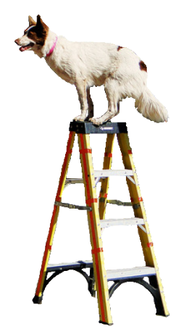
Climb a ladder- For this exercise, a short 4’ ladder with open steps/rungs is ideal. Flat steps are safest because it gives the dog a solid place for his feet. The ladder should go to a safe raised surface for the dog (unlike the photo to the right). The dog should NOT jump off the top of the ladder. It can be built using 1x4 or 2x4 boards which is a good option for smaller dogs that might have trouble with the standard step spacing of a ladder. The dog does need to CLIMB the ladder and not just jump over the rungs to the raised surface. For safety, be sure the ladder is stable and placed in a way that it doesn’t wobble or shake excessively. The ladder should be at a typical ladder angle; not vertical or excessively shallow. Alternate items need spaces between the rungs that are wide enough and rungs that are narrow enough to provide a challenge to the dog. Rungs should not be closer than 8” apart (for smaller dogs). Medium to large dogs should use a ladder with standard 12” rung/step spacing.

Horizontal, elevated “ladder”- This should be at least 8’ long and between 1’ and 3’ off the ground. The concept is a ladder laid across an opening to be used by the dog to get from one side to the other and shows that the dog has good control over his foot placement. The dog should be stepping on the ladder rungs and should not need assistance from the human (though the handler can be right next to the dog and act as a “spotter” by holding a harness on the dog (in a way that does not assist the dog) or by putting hands under the dog without contact. If the dog tries to “cheat” and use the sides of the ladder, you might need to build or use a wider ladder. Items that create the same behavior may be used in place of an actual ladder as long as the dog’s foot/leg won’t get caught if the dog slips causing his leg/foot to fall through. Slats/rungs should be 1.5” – 2.5” wide and spaces between the rungs should be 8”-12”. The ladder should not wobble or move.
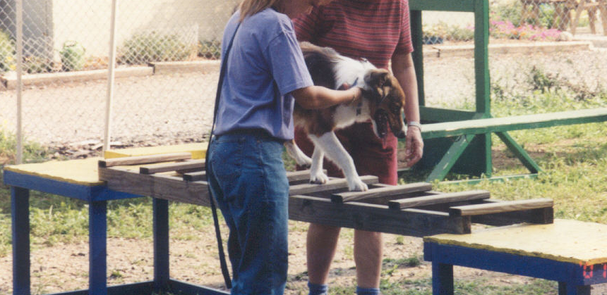
(Photo from: http://www.vincerambaladogtraining.com)
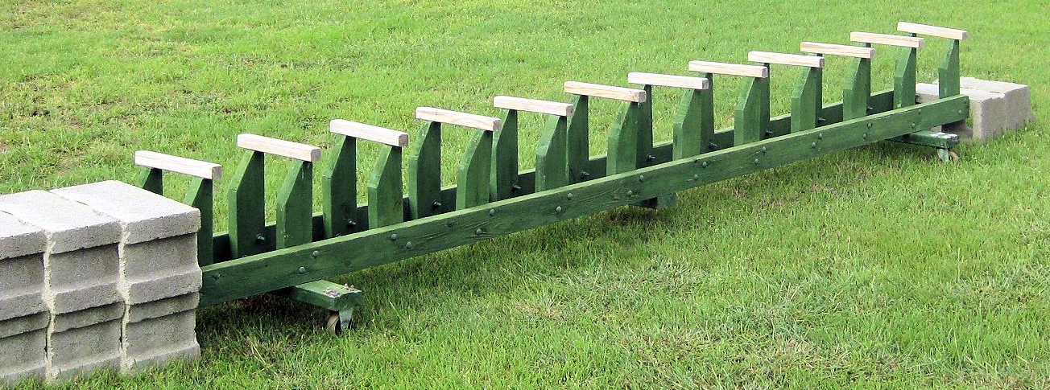

“Rail-less ladder”
(For dogs that try to use the sides of a standard ladder instead of the rungs)

Between two solid surfaces (“Squeeze tunnel”) - This simulates squeezing through narrow/low spaces in the rubble and the dog should need to belly crawl. Instructors working with several sizes of dogs will need a way to adjust the opening to about the height of the dog’s withers when the dog is in a “sphinx” down position (can add up to 1.5” to dog’s measurement). This obstacle will not likely need to be taller than 18” so stacking 2x4’s or 2x6’s as the sides with a piece of plywood over it should work fine. Using a pin system that is sunk in the ground or bracing the 2x4’s with cinder blocks to be sure they don’t collapse if the dog hits them is highly recommended. The bottom of the tunnel must be solid, such as plywood or paving stones, but can be covered with thin carpet if desired. Width of this obstacle should be a maximum 24” wide (between inside edges) and the tunnel should be 6-8’ long. This obstacle will need a removable top in case the dog gets scared but the movement of the dog through the tunnel should not lift the top. The area surrounding the crawl tunnel opening can be blocked off to prevent the dog from going around or over the top of the tunnel if desired. But the fencing or other objects used to block the dog must not interfere with the removal of the top of the tunnel. It is recommended that the tunnel be slightly raised off the ground to assist the dog during entry and exit, but raising the tunnel is not required.
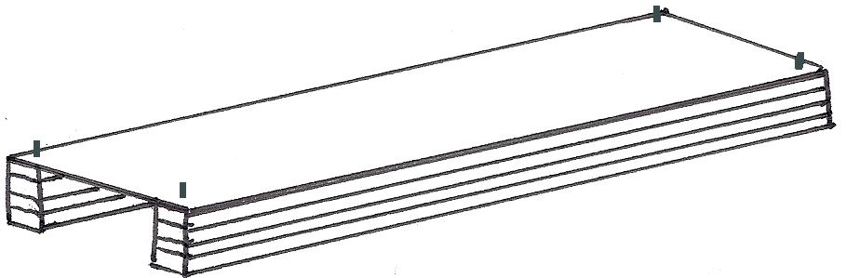

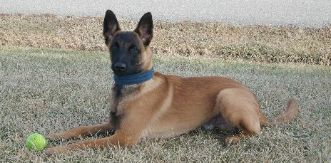

The space between the floor of the tunnel and the top of the tunnel should be the same as the height of the dog’s withers while the dog is in the “sphinx” position (as shown to the right). If needed (because of the way the tunnel is constructed) up to 1.4” can be added to this measurement.

