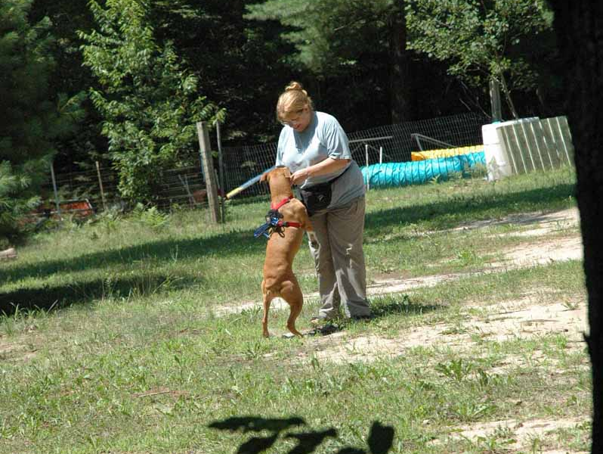
Kozi Practices “Go Find Jo!” with my Primary Handler, Joanne Weber. It helps that Kozi already knows who “Jo” is, because we’re friends. Jo tells her to “Go To Lonnie”, and Kozi returns to me.
Messenger Dog Training by Lonnie Olson
We do this farther and farther apart, and out of sight until the dog is getting it.

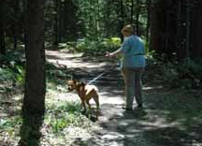

Primary Handler (Jo) leaves with dog, saying “Bye, Lonnie!” Lonnie says, “Kozi, Go with Jo…Bye, Jo!”
They walk on down the trail for 200 yards. Please, if the dog looks back over her shoulder at the Secondary Handler, PRAISE her! Don’t “correct” her for not wanting to walk away with you. We want her to come back to that person and home in on her more than anything!

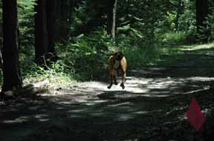
Jo has an urgent Message, so writes it down and places it in the pouch on Kozi’s harness (a cell phone case that velcros onto the harness). Jo sends Kozi to “Go To Lonnie”. Kozi comes barreling down the trail to the Home Base, where she last left Lonnie. The leash must either be securely fastened, or removed entirely and a separate leash kept by the Secondary Handler, for the safety of the dog (running through brush at top speeds). I used the two leash method for Kozi. You can see she’s airborne!
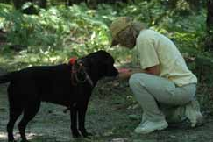
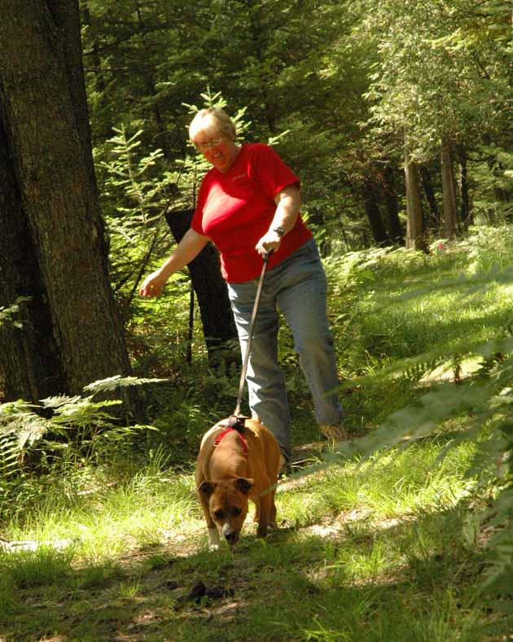
On Cassy’s turn, Fay (Secondary Handler) and Cassy read the note and find that it’s urgent to find Jo. She wants to rendezvous at the outpost. *(we didn’t get a photo of Lonnie reading the note… the photographer was in the woods looking for great action shots of the dogs trailing their Primary Handlers). Note Cassy’s securely fastened leash (with Velcro) on the harness.

Kozi takes Lonnie back down the trail to where she last left Joanne. The dog can follow the scent trail for this, or just go from memory to the place she was just released from.

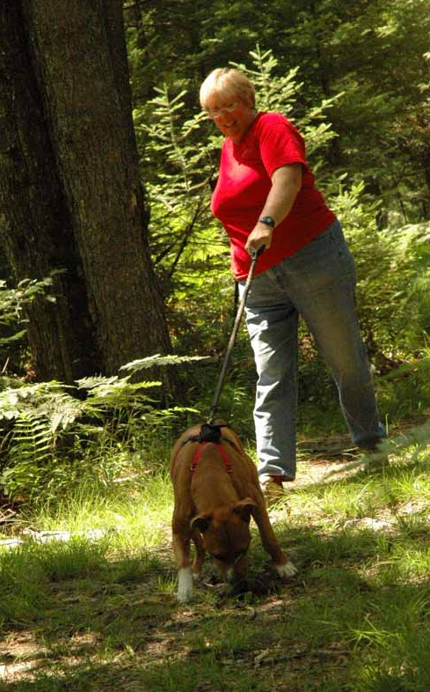
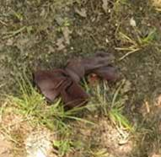
Meanwhile, Jo has had to leave the outpost and move to a new location. She has no breadcrumbs to help lead them to her new location, so she leaves a scent article (her Socks), to let Kozi do the rest.

Kozi has reached the outpost, but all she finds there is a scent article (pair of Jo’s socks).
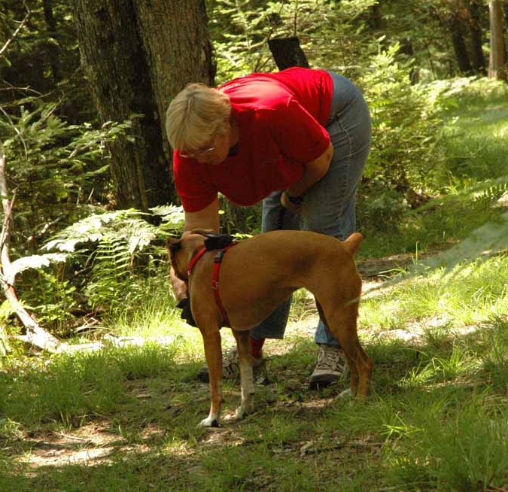
Lonnie picks up and gives Kozi the scent, telling her to “Find Jo!” or whatever cue you have been using. Jo is hiding out of sight and off the trail at least another 100 yards further on…

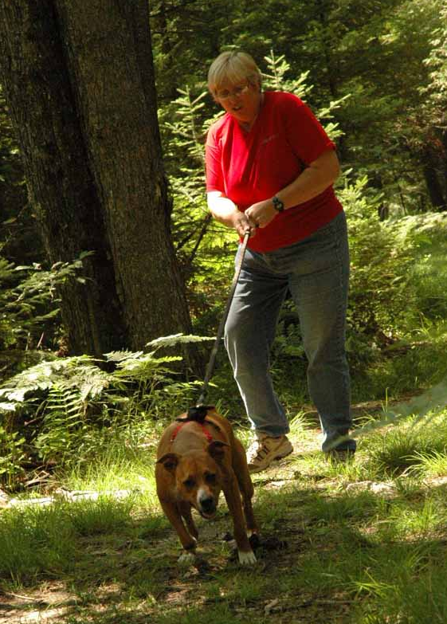
Kozi resumes the hunt for Joanne. At this point you may see your dog pay more attention to the ground, because that’s the only clue they have for this portion of the trail (the scent). Your dog does not have to perform “footstep tracking” for this exercise. Many of the dogs move down the trail at speed. But don’t go so fast that you can’t READ your dog. You should be able to tell when the dog is working, if you’ve had the prerequisite Tracking or SAR badges. The handler must not lead the dog. The dog must be pulling the handler down the trail toward the object of her search. I would not “run” with the dog at this point. Let her pull you.

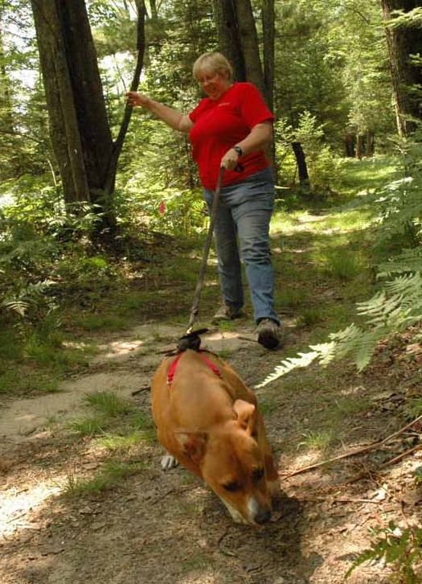

Kozi is pulling so hard, I can barely keep my balance. She sees Fay (taking photos) in the bushes, but dismisses her as the wrong person, and doesn’t even stop to acknowledge her.

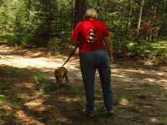

At the fork in the road, Kozi pays particular attention to where Jo walked, and takes the correct turn (left).

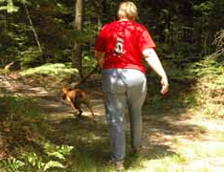

She’s really pulling hard as she gets closer to her target (the scent is fresher). She’s hot on her trail.

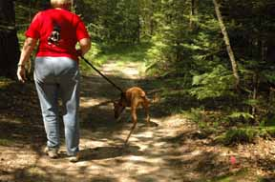
Oops! The trail seems to run out here… Kozi is searching for clues. Notice how I let her work it out, and don’t try to lead her in any direction (I’d probably be wrong!). Let your dog puzzle it out.

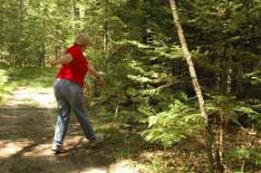

She hangs a right, dragging me into the brush!

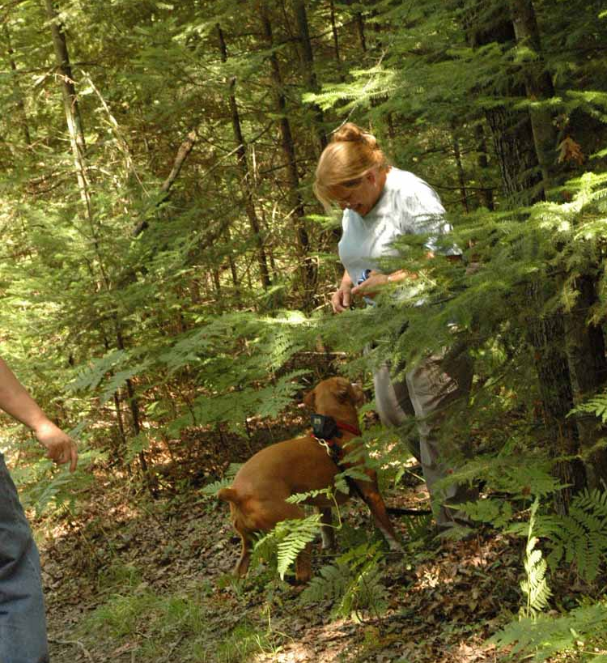

Kozi has found her “man!” She tracked through the dense cover to find Jo hidden behind a tree. When she got very close to Jo, I had to let go of the leash as she was really charging after her!

The proof is in the pudding. If the dog finds her “man,” you’ve pretty much got the badge. However, if you are “leading the dog,” or if the dog goes the wrong way and doesn’t turn back on her own to correct herself, or if a twig snaps, or the person sneezes and gives away their hiding spot, you’ll have to repeat the whole thing and let the dog find you on the basis of scentwork alone.

Thanks to Fay Reid for these excellent photos (I took the one of Fay, when Cassy was searching for Jo).

If dogs know a phrase, like, “Where’s Daddy?” Or they already know how to find a member of your family when asked to search for them, it will help out dramatically. Dogs with no tracking experience at all have actually passed this badge (the handler had experience). If the dog has a mission (Find Daddy), and she has nothing to go on, she will fall back on her very capable sense of smell to do the job. Dogs don’t have to be trained to use their noses and trail someone… They do that automatically. They just need to learn what scent we want them to follow. For them, its as easy as if someone had painted red arrows on the ground leading to the hiding person. They just read the signs.
As we say in Search and Rescue… “Trust the Dog.”

