In addition to the information and training videos on the DSA website, the following books are highly recommended reading for everyone interested in Dog Scout Certification. The information included may be helpful in completing the Handler Written Test. but especially Troop Leaders, Scoutmasters and Dog Scout Evaluators. Click on the pictures below for purchase information.
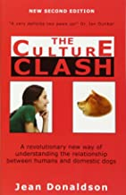

The Culture Clash, by Jean Donaldson (ISBN: 1-888047-05-4)

This book is a revolutionary way of understanding the relationship between humans and dogs. It gives a keen insight into the dog’s mind in terms everyone can relate to and understand. If only one book could be recommended to a dog owner, this would be the one! This book is required reading for Troop Leaders, Scoutmasters and Specialty Badge Evaluators.

The Other End of the Leash, by Dr. Patricia McConnell (ISBN: 0-345-44679-8) This humorous, well-written book tells us what to do and what to avoid based on years of studying dogs and their primate owners. Written with clarity, insightfulness, charm and humor it is a must read for everyone that holds a leash. This book is required reading for Troop Leaders, Scoutmasters and Specialty Badge Evaluators.
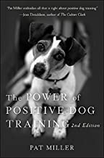

The Power of Positive Dog Training, by Pat Miller (ISBN:0-7645-36095) Learn all about positive training from the very basic first steps, through a six-week training course. Both beginners and experienced trainers will find this an invaluable resource.

Video: Clicker Magic, by Karen Pryor (ISBN 1-890948-01-2) Karen Pryor teaches you all the techniques and essentials you will need to have your pet clicker trained in no time! There are 20 live demonstrations by Karen and old dogs, cats, a mule and even a fish! Long considered the standard, Clicker Magic, provides a solid introduction and inspiring, fantastic footage. Running time 55 minutes

Website - www.ClickerTraining.com This is Karen Pryor’s official web site and has lots of helpful articles and information about using positive training.

Website - www.clickersolutions.com/index.html This site has an email list and lots of links to other all positive information including a detailed list of books, videos, talk lists and web sites.

