Drill Team Performance

By Lonnie Olson

Drill Teaming has been around for a long time, but many people are new to it. The best way to explain it is that it is like dancing with dogs in groups. It is like being in a marching band or a Miss America pageant, but with a dog instead of a musical instrument or other props. It’s like synchronized Musical Canine Freestyle.

Basically, teams of people from four to forty can line up, walk in patterns, do grand marches, weave in and out of each other, and do pinwheels. The dogs perform various obedience exercises, like heeling, instant drops, stays, recalls and grapevine weaves, choreographed to music.

It’s a lot of fun. I used to do it with the Superdog shows in Canada. I have included some photos from 15 years ago, when my group was performing in Manitoba. We did several routines to entertain the crowds at the Red River Exhibition.
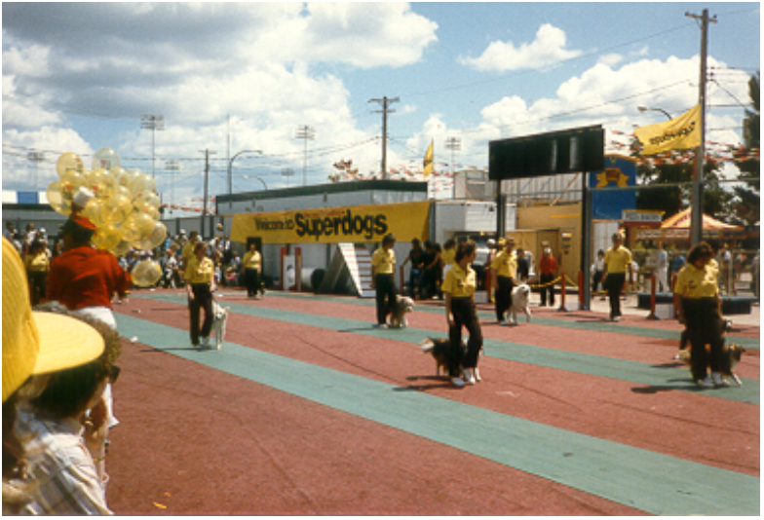

This is a group from Manitoba, called the “Can-Do Canines” performing a drill marching routine for the Superdog shows in Canada.
This team is very good. Notice they’re all on the right foot.

To perform drill team exercises, you have to have a sense of timing, be able to walk in time to the music, be on the correct foot at the right time, count off beats of music, and control your dog.

To be a good team member, imagine you are a Radio City Music Hall “Rockette.” When walking forward in a straight line, look to the left, and line up with the person on the end. If everyone does that, the line will be very straight. People have to take uniformly sized steps, except in the case of doing a pinwheel.

For a pinwheel, the center people just pick up their feet and pivot in place, and the end people take huge, quick strides to keep in time with the music, and still move faster than the inside of the circle.

When doing a basket weave, spacing is important. If you keep your strides and spacing equal, you will not crash into the other dog and handler, when you cross in front of them. You have to actually “aim” for the person who is in front of them, so that when you actually get there, a step and a half later, that person will be gone, and your empty space will be there to walk through.

It looks nicer if you can really pick up your knees and march, but it also looks very nice to just do a little shuffle step. Regardless of the style of step your team uses, everyone on the team should walk similarly. Everyone must make an attempt to start on the correct foot (the left), and stay on the correct foot, by keeping time with the beats of the music. Sometimes drill teams don’t pay much attention to the actual beats of music, and I don’t feel that it looks as nice. The shuffle steps are cool, and they are less tiring, and easier to keep with the beat. Plus, if you opt for the marching steps, you’ll always get one or more “showmen” who pick ‘em up and put ‘em down like the “Music Man”, and someone else will be shuffling or stumbling around making the group look sloppy. Everyone should do the same type of step, or just WALK naturally to the beat (or NOT to the beat—but that should be decided before hand).
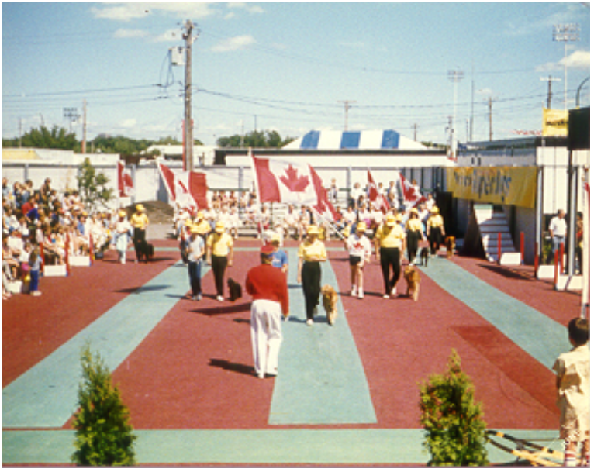
Here is our group, doing a drill routine with kids. We grabbed some kids out of the audience and had them follow us through the routine. Their job was to “heel” (follow us and keep up with us), but since they didn’t know the routine, we often had to physically guide them. The kids carried the Canadian Flags (which made it easier for us to work the dogs), and it made the performance more colorful.

It goes without saying that your dog must be under good control. He should respond instantly to every cue, so that it will fit with the music. If your dog does not heel with precision, you can use a short tag line, with which you can maintain contact with your dog. The tag line also makes it possible to take your eyes off the dog, as it looks so much nicer when you have your head up, smiling, during the performance, than when you’re looking at your dog and all people can see is the top of your head.

The dog should also be used to working around all kinds of distractions, and ignoring crowds of people and noise. When you give the dog a cue, he should be paying attention, and respond right away (like to lie down). If you are to keep marching, you have to keep going with the music, and it will look bad if your dog crawls forward or keeps following you when he was supposed to drop. Also, sometimes we have to call our dogs out of a line up, one at a time. Your dog must be very solid on his cues, and not respond to someone else’s call.

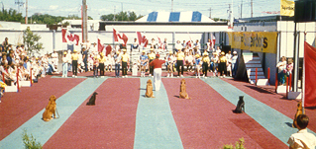
For this routine, we had to sit our dogs and walk away, all in one motion. If the dogs hesitated, they would be in the wrong spot on the field when the owner returns to “pick up” the dog on a specific beat of music.

This year, at the June 10 – 15, 2002 Dog Scout Camp, Jennifer Riess, from Missouri will teach the Drill Team exercises for a merit badge activity.

